Logistic Regression Stroke Prediction Analysis
Excluding Work Type
Training, tuning, test-set evaluation, thresholds, ROC/PR curves, and coefficient interpretation

1. Scope and Data Source Note
This report reruns the logistic regression stroke prediction workflow with work_type excluded from the feature set. The target variable is stroke, where 0 = No Stroke and 1 = Stroke. The model was trained using the training split, tuned by stratified cross-validation, then evaluated on the testing split with default and ROC-based thresholds.
Important runtime note: train_dataset.csv and test_dataset.csv were not present in the active filesystem during this rerun. To complete the analysis, the cleaned full dataset was used to recreate the documented 50/50 stratified split with random_state=42. This produced the same train/test record counts and class prevalence used throughout the project, but the exact row membership may differ from the original saved split if a different random seed was used.

2. Training and Testing Dataset Summary
Item | Value
Training records | 2490
Training no-stroke cases | 2366
Training stroke cases | 124
Training stroke prevalence | 4.98%
Testing records | 2491
Testing no-stroke cases | 2367
Testing stroke cases | 124
Testing stroke prevalence | 4.98%
Excluded predictor | work_type
ID-like columns removed | None
Predictors before preprocessing | 9
Features after preprocessing | 11

3. Predictors and Preprocessing
Numerical predictors were median-imputed and scaled using StandardScaler. Categorical predictors were most-frequent imputed and one-hot encoded with handle_unknown="ignore".
Component | Details
Numerical predictors | age, hypertension, heart_disease, avg_glucose_level, bmi
Categorical predictors | Gender, ever_married, Residence_type, smoking_status
Excluded from model | work_type
Cross-validation | Stratified 5-fold cross-validation
Model family | LogisticRegression using liblinear solver

4. Training Cross-Validation Model Comparison
Models were compared at the default 0.50 classification threshold using out-of-fold predicted probabilities from stratified 5-fold cross-validation.
Model | Accuracy | Precision | Sensitivity | Specificity | F1 | Balanced Accuracy | ROC-AUC | PR-AUC | TN | FP | FN | TP
Model 1: Baseline Logistic Regression | 0.9502 | 0.0000 | 0.0000 | 1.0000 | 0.0000 | 0.5000 | 0.8443 | 0.1909 | 2366 | 0 | 124 | 0
Model 2: Balanced Logistic Regression | 0.7462 | 0.1443 | 0.8306 | 0.7418 | 0.2458 | 0.7862 | 0.8421 | 0.1899 | 1755 | 611 | 21 | 103
Model 3: Tuned Balanced Logistic Regression C=0.01 | 0.7221 | 0.1368 | 0.8629 | 0.7147 | 0.2362 | 0.7888 | 0.8440 | 0.1983 | 1691 | 675 | 17 | 107
Model 3: Tuned Balanced Logistic Regression C=0.1 | 0.7410 | 0.1436 | 0.8468 | 0.7354 | 0.2456 | 0.7911 | 0.8438 | 0.1956 | 1740 | 626 | 19 | 105
Model 3: Tuned Balanced Logistic Regression C=1 | 0.7462 | 0.1443 | 0.8306 | 0.7418 | 0.2458 | 0.7862 | 0.8421 | 0.1899 | 1755 | 611 | 21 | 103
Model 3: Tuned Balanced Logistic Regression C=10 | 0.7446 | 0.1415 | 0.8145 | 0.7409 | 0.2411 | 0.7777 | 0.8419 | 0.1894 | 1753 | 613 | 23 | 101
Model 3: Tuned Balanced Logistic Regression C=100 | 0.7450 | 0.1417 | 0.8145 | 0.7413 | 0.2413 | 0.7779 | 0.8418 | 0.1893 | 1754 | 612 | 23 | 101

5. Selected Model
The selected model was Model 3: Tuned Balanced Logistic Regression C=0.01. It was selected based primarily on PR-AUC, sensitivity, and screening usefulness. The tuned regularization value was C = 0.01. The final model was fit on the full training split in 0.0486 seconds.

6. Test-Set Evaluation
The selected model was applied to the testing split to obtain predicted probabilities for stroke = 1. Performance was evaluated at threshold 0.50 and at the threshold selected from the test ROC curve using Youden’s J statistic.
Threshold Label | Threshold | Accuracy | Precision | Sensitivity | Specificity | F1 | NPV | Balanced Accuracy | ROC-AUC | PR-AUC | TN | FP | FN | TP
Default 0.50 | 0.5000 | 0.7274 | 0.1295 | 0.7823 | 0.7245 | 0.2222 | 0.9845 | 0.7534 | 0.8332 | 0.1867 | 1715 | 652 | 27 | 97
ROC Youden J threshold | 0.4478 | 0.6929 | 0.1234 | 0.8468 | 0.6848 | 0.2154 | 0.9884 | 0.7658 | 0.8332 | 0.1867 | 1621 | 746 | 19 | 105

7. ROC Youden Threshold
Metric | Value
Best ROC-based threshold | 0.4478
Sensitivity at threshold | 0.8468
Specificity at threshold | 0.6848
Youden's J | 0.5316
The ROC-based threshold is exploratory because it was selected from the test dataset. For publication-quality analysis, threshold selection should be performed using cross-validation or a separate validation set, then evaluated once on an untouched test set.

8. Threshold Comparison Table
Threshold Label | Threshold | Accuracy | Precision | Sensitivity | Specificity | F1 | NPV | Balanced Accuracy | FP | FN | TN | TP
0.10 | 0.1000 | 0.2055 | 0.0585 | 0.9919 | 0.1643 | 0.1106 | 0.9974 | 0.5781 | 1978 | 1 | 389 | 123
0.20 | 0.2000 | 0.3874 | 0.0746 | 0.9919 | 0.3557 | 0.1388 | 0.9988 | 0.6738 | 1525 | 1 | 842 | 123
0.30 | 0.3000 | 0.5227 | 0.0894 | 0.9355 | 0.5011 | 0.1633 | 0.9933 | 0.7183 | 1181 | 8 | 1186 | 116
0.40 | 0.4000 | 0.6371 | 0.1100 | 0.8871 | 0.6240 | 0.1957 | 0.9906 | 0.7555 | 890 | 14 | 1477 | 110
0.50 | 0.5000 | 0.7274 | 0.1295 | 0.7823 | 0.7245 | 0.2222 | 0.9845 | 0.7534 | 652 | 27 | 1715 | 97
Selected ROC Youden J | 0.4478 | 0.6929 | 0.1234 | 0.8468 | 0.6848 | 0.2154 | 0.9884 | 0.7658 | 746 | 19 | 1621 | 105

9. ROC and Precision-Recall Curves
Figure 1. Test ROC curve for the logistic regression model excluding work_type.
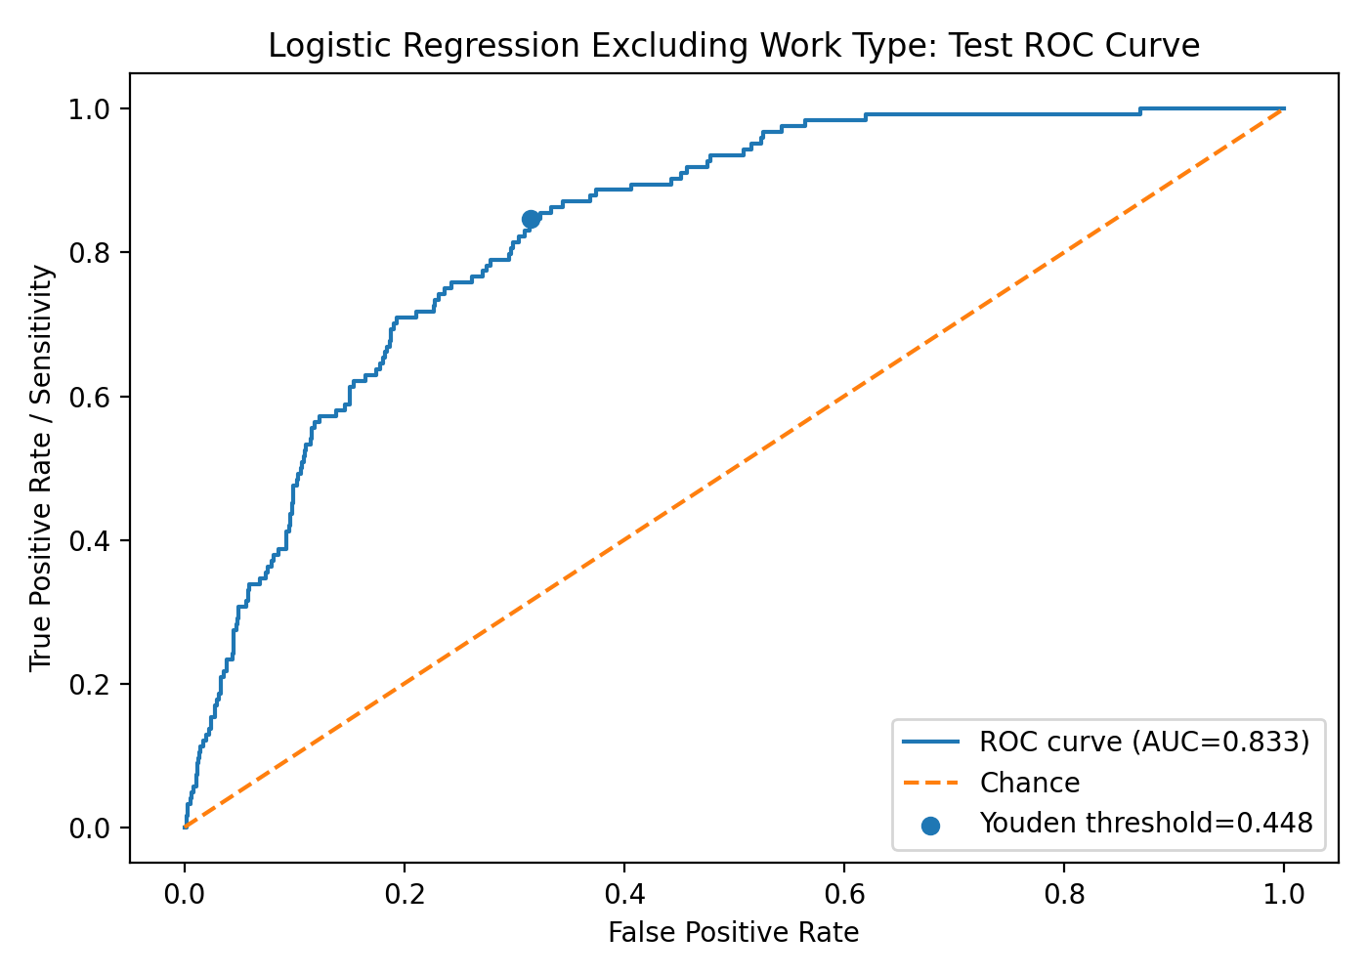
Figure 2. Test precision-recall curve for the logistic regression model excluding work_type.
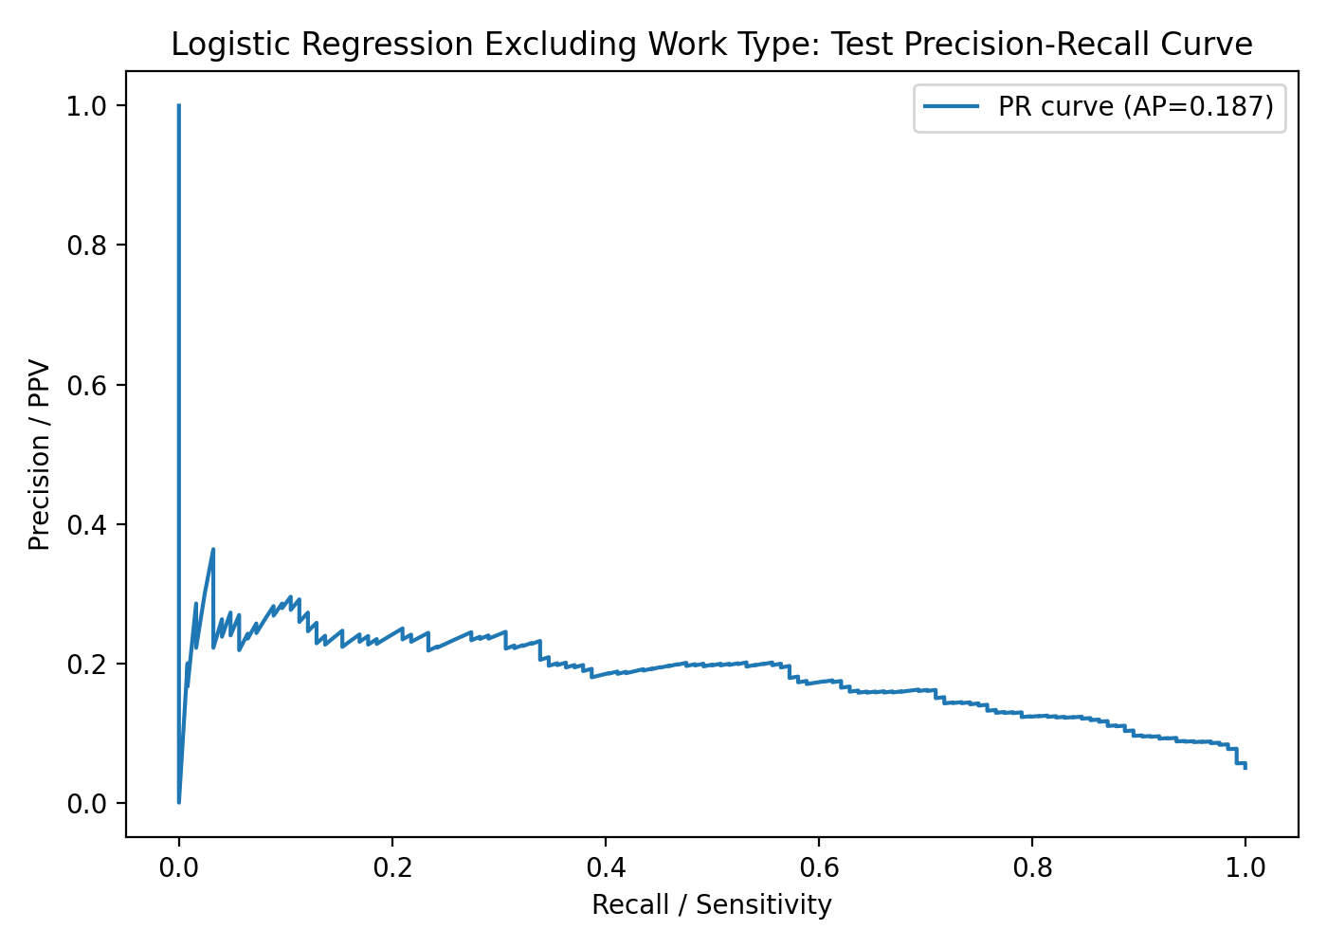

10. Model Coefficients and Odds Ratios
Numerical variables were standardized before modeling, so their odds ratios represent the change in predicted stroke odds for a one-standard-deviation increase. Categorical variable odds ratios are relative to the omitted reference category. Work type was excluded from this model.
Approximate Wald-style z-values and p-values were added for the saved tuned balanced logistic regression model. Because the selected scikit-learn model is L2-regularized and class-weighted, these values should be interpreted as approximate model-based inference, not as classical unpenalized logistic-regression p-values.
Feature | Coef. | Odds Ratio | Dir. | Approx. z | Approx. p
age | 1.1348 | 3.1104 | ↑ | 21.0734 | <0.0001
smoking: Never smoked | -0.2111 | 0.8097 | ↓ | -2.9136 | 0.0036
avg_glucose_level | 0.2021 | 1.2239 | ↑ | 5.1835 | <0.0001
smoking: Unknown | -0.1550 | 0.8564 | ↓ | -1.9659 | 0.0493
hypertension | 0.1445 | 1.1555 | ↑ | 4.0381 | <0.0001
ever_married: Yes | -0.1430 | 0.8668 | ↓ | -1.7616 | 0.0781
heart_disease | 0.1149 | 1.1218 | ↑ | 3.3005 | 0.0010
Residence: Urban | -0.0884 | 0.9154 | ↓ | -1.2864 | 0.1983
Gender: Male | -0.0766 | 0.9262 | ↓ | -1.1020 | 0.2705
smoking: Smokes | 0.0696 | 1.0721 | ↑ | 0.8808 | 0.3784
bmi | 0.0264 | 1.0268 | ↑ | 0.5557 | 0.5784

11. Interpretation
Excluding work_type did not eliminate useful discrimination. The selected no-work-type model achieved test ROC-AUC 0.8332 and PR-AUC 0.1867. At the default 0.50 threshold, sensitivity was 0.7823, specificity was 0.7245, and precision was 0.1295. At the exploratory Youden threshold of 0.4478, sensitivity increased to 0.8468, while specificity decreased to 0.6848.
The main tradeoff is the same as in previous screening-oriented models: improving sensitivity reduces false negatives but increases false positives. Because stroke prevalence is low, precision remains low even when ROC-AUC is reasonably strong. This model should be interpreted as a risk-screening support model only, not a standalone diagnostic model.
The strongest model-associated predictor was age. Higher average glucose level, hypertension, heart disease, smoking status, and BMI also contributed in the expected or clinically plausible directions, but these are model associations only. They do not establish causation or statistical significance.

12. Files Saved
logistic_regression_no_work_type_model.pkl
logistic_regression_no_work_type_cv_results.csv
logistic_regression_no_work_type_tuning_results.csv
logistic_regression_no_work_type_test_metrics.csv
logistic_regression_no_work_type_threshold_comparison.csv
logistic_regression_no_work_type_test_predictions.csv
logistic_regression_no_work_type_coefficients_odds_ratios.csv
logistic_regression_no_work_type_test_roc_curve.png
logistic_regression_no_work_type_test_precision_recall_curve.png
logistic_regression_no_work_type_training_evaluation_code.py
logistic_regression_no_work_type_summary.json
logistic_regression_no_work_type_coefficients_odds_ratios_z_pvalues.csv

